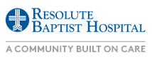

**Handicap and ED Parking**

**Main Parking Lot**

**Main Street**

Cool Beans Coffee

Leaf Café

7AM – 9AM

11AM – 3AM

To ER

Main Entrance

To YMCA and HealthLink

Restrooms

HR and MOB Classrooms

Suite 106

**(830) 500-6000**