San Antonio Emergency Nurses Association
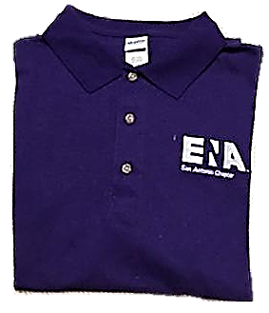
SAENA Chapter Shirts!

Cost of shirts:
S-XL- $16
2X - $18
3X - $20
4X - $22
5X - $24
Shipping is extra!

Save money!
Free Delivery at an SAENA meeting!

Shirts are polo style and made from 50% cotton and 50% polyester.
To order shirts contact Danny Ruano at dannyruano@hotmail.com.
Shirts will be ordered only upon receipt of payment.
No refunds
Expect 2-3 weeks for delivery

